DSA LAB 11
QUESTION O1
CODE
//SABA SHAHID
// 02-134241-048
// CS 3-A

#include <iostream>
#include <string>
using namespace std;

//QUESTION 01
struct Player {
string name;
int rating;
};

Player heap[100];
int MAX_HEAP = 100;
int sizeOfHeap = 9;

void initializeHeap() {
Player initialPlayers[] = {
{"Ayesha", 8.3},
{"Usman", 7.1},
{"Fatima", 9.2},
{"Bilal", 6.5},
{"Zainab", 8.7},
{"Ali", 5.9},
{"Hira", 7.8},
{"Ahmed", 6.4},
{"Sana", 8.0}
};
for (int i = 0; i < 9; i++) {
heap[i] = initialPlayers[i];
}
}

void swapPlayers(Player& a, Player& b) {
Player temp = a;
a = b;
b = temp;
}

// bottom to top fixing the heap after insertion
void heapifyUp(int i) {
// Jab tak parent se bara hai aur root nahi hai
while (i > 0 && heap[(i - 1) / 2].rating < heap[i].rating) {
swapPlayers(heap[(i - 1) / 2], heap[i]); // Parent se swap
i = (i - 1) / 2; // Parent index par ja rae
}

}

// delete hone par heap ko theek kare (top to bottom)
void heapifyDown(int i) {
int largest = i;
int left = 2 * i + 1;
int right = 2 * i + 2;

// Agar left child hai aur zyada rating wala hai
if (left < sizeOfHeap && heap[left].rating > heap[largest].rating)
largest = left;

// Agar right child hai aur zyada rating wala hai
if (right < sizeOfHeap && heap[right].rating > heap[largest].rating)
largest = right;

// Agar koi child parent se bara hai
if (largest != i) {
swapPlayers(heap[i], heap[largest]); // swapping Parent and child
heapifyDown(largest); // fixing neechay wala sub tree
}
}

// INSERTION
void insertPlayer(string name = "", int rating = 0) {
if (sizeOfHeap >= MAX_HEAP) {
cout << "Heap full\n";

return;
}
if (name == "") {
cout << "Enter name and rating: ";
cin >> heap[sizeOfHeap].name >> heap[sizeOfHeap].rating;
}
else {
heap[sizeOfHeap].name = name;
heap[sizeOfHeap].rating = rating;
}
heapifyUp(sizeOfHeap++);
}

// DISPLAY
void displayHeap() {
for (int i = 0; i < sizeOfHeap; i++)
cout << heap[i].name << " (" << heap[i].rating << ")\n";
}

//HIGHEST RATED PLAYER
void getTopPlayer() {
if (sizeOfHeap == 0) cout << "Heap empty\n";
else cout << "Top: " << heap[0].name << " (" << heap[0].rating << ")\n";
}

// DELETE
void deletePlayer() {
if (sizeOfHeap == 0) {
cout << "Heap empty\n";
return;
}
cout << "Deleting highest rated player: " << heap[0].name << " (" << heap[0].rating << ")\n";
heap[0] = heap[--sizeOfHeap]; // putting last player iski jagah par
heapifyDown(0); // Heap property ko maintaining
}

void main() {
initializeHeap();
cout << "The List of Players is:\n";
displayHeap();
cout << endl;
insertPlayer();
cout << "Displaying the top player:\n";
getTopPlayer();
cout << endl;
cout << "Deletion :\n";
deletePlayer();
cout << "The List of Players after deletion :\n";
displayHeap();
cout << endl;
}
OUTPUT
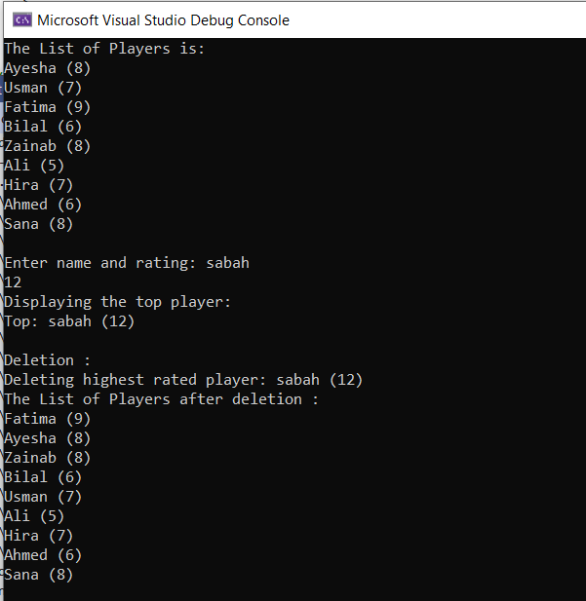
QUESTION O2
CODE
//SABA SHAHID
// 02-134241-048
// CS 3-A
#include <iostream>
#include <string>
using namespace std;

//QUESTION NO 02

struct Recipe {
string name;
int time;
};

Recipe heap[100];
int heapSize = 0;

void swap(int a, int b) {
Recipe temp = heap[a];
heap[a] = heap[b];
heap[b] = temp;
}

void heapifyUp(int i) {
while (i > 0 && heap[(i - 1) / 2].time > heap[i].time) {
swap(i, (i - 1) / 2);
i = (i - 1) / 2;
}
}

void heapifyDown(int i) {
int smallest = i;
int left = 2 * i + 1;
int right = 2 * i + 2;

if (left < heapSize && heap[left].time < heap[smallest].time)
smallest = left;
if (right < heapSize && heap[right].time < heap[smallest].time)
smallest = right;
if (smallest != i) {
swap(i, smallest);
heapifyDown(smallest);
}
}

void insert(string name, int time) {
heap[heapSize] = { name, time };
heapifyUp(heapSize++);
}

void getMin() {
if (heapSize == 0) {
cout << "No recipes\n";
return;
}
cout << "Fastest: " << heap[0].name << " (" << heap[0].time << " mins)\n";
}

void removeMin() {
if (heapSize == 0) return;
heap[0] = heap[--heapSize];
heapifyDown(0);
}

void heapSort() {
cout << "Recipes in increasing time order:\n";
for (int i = 0; i < heapSize; i++)
cout << heap[i].name << " (" << heap[i].time << " mins)\n";
}

int main() {
cout << "Inserting recipes......\n";
insert("Pasta", 15);
insert("Omelette", 5);
insert("Biryani", 60);
insert("Paratha", 10);
insert("cake", 65);
insert("karahi", 40);

cout << "\nThe recipe with least time is:\n";
getMin();
cout << endl;
heapSort();

cout << "\nDeleting the recipe with least time......\n";
removeMin();

cout << "\nRecipe with least time now is:\n";
getMin();

return 0;
}
OUTPUT
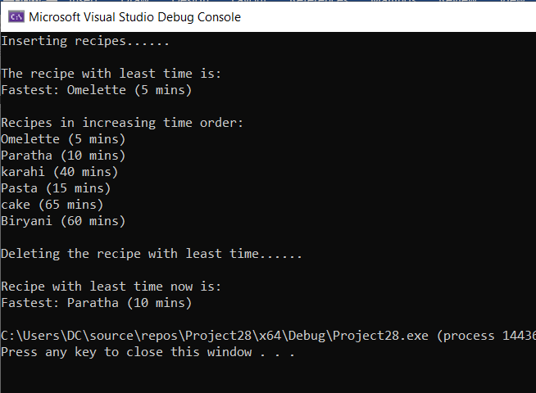
QUESTION 03
CODE
//SABA SHAHID
// 02-134241-048
// CS 3-A
#include <iostream>
#include <string>
using namespace std;

//QUESTION O3

struct Patient {
string name;
int priority;
};

Patient heap[100];
int sizee = 0;

void minHeapify(int index) {
int smallest = index;
int left = 2 * index + 1;
int right = 2 * index + 2;

if (left < sizee && heap[left].priority < heap[smallest].priority)
smallest = left;
if (right < sizee && heap[right].priority < heap[smallest].priority)
smallest = right;
if (smallest != index) {
swap(heap[index], heap[smallest]);
minHeapify(smallest);
}
}

void insertPatient(string name, int priority) {
if (sizee >= 100) {
cout << "Queue is full!" << endl;
return;
}
heap[sizee] = { name, priority };
sizee++;

int i = sizee - 1;
while (i != 0 && heap[(i - 1) / 2].priority > heap[i].priority) {
swap(heap[i], heap[(i - 1) / 2]);
i = (i - 1) / 2;
}
}

void displayQueue() {
if (sizee == 0) {
cout << "Queue is empty!" << endl;
return;
}
for (int i = 0; i < sizee; i++) {
cout << heap[i].name << " (Priority: " << heap[i].priority << ")" << endl;
}
}

void viewNextPatient() {
if (sizee > 0) {
cout << "Next patient: " << heap[0].name << endl;
}
else {
cout << "Queue is empty!" << endl;
}
}

void treatNextPatient() {
if (sizee == 0) {
cout << "Queue is empty!" << endl;
return;
}
cout << "Treating: " << heap[0].name << endl;
heap[0] = heap[sizee - 1];
sizee--;
minHeapify(0);
}

int main() {

insertPatient("John", 5); // Regular
insertPatient("Sarah", 2); // Old Age
insertPatient("Tommy", 3); // Child
insertPatient("Alex", 4); // New
insertPatient("Lisa", 1); // Emergency

cout << "Current Queue:" << endl;
displayQueue();
cout << endl;

viewNextPatient();
treatNextPatient();
cout << endl;

viewNextPatient();
treatNextPatient();
cout << endl;

cout << "Remaining Queue:" << endl;
displayQueue();

return 0;
}
OUTPUT
